Culture, Heritage, Food and Traditions of Maharashtra
Pandharpur Wari is a historic 21-day annual pilgrimage in Maharashtra. Thousands of devotees walk to the Vithoba temple in Pandharpur, carrying the holy paduka of saints like Sant Dnyaneshwar and Sant Tukaram in palkhis to celebrate Ashadi Ekadashi.  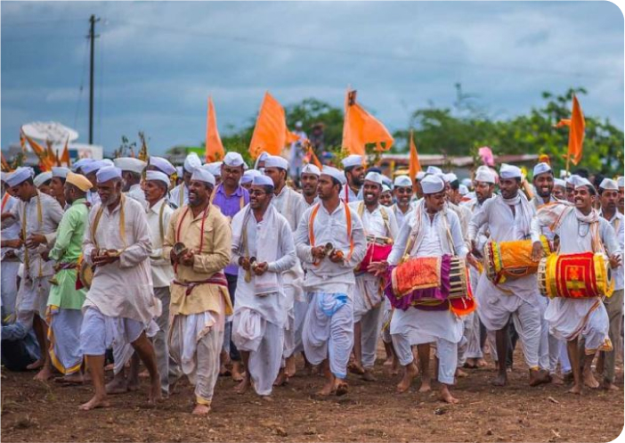 | Puran poli is a famous sweet flatbread from India made with chana dal, jaggery, and ghee. It is a soft flatbread stuffed with a sweet lentil filling.  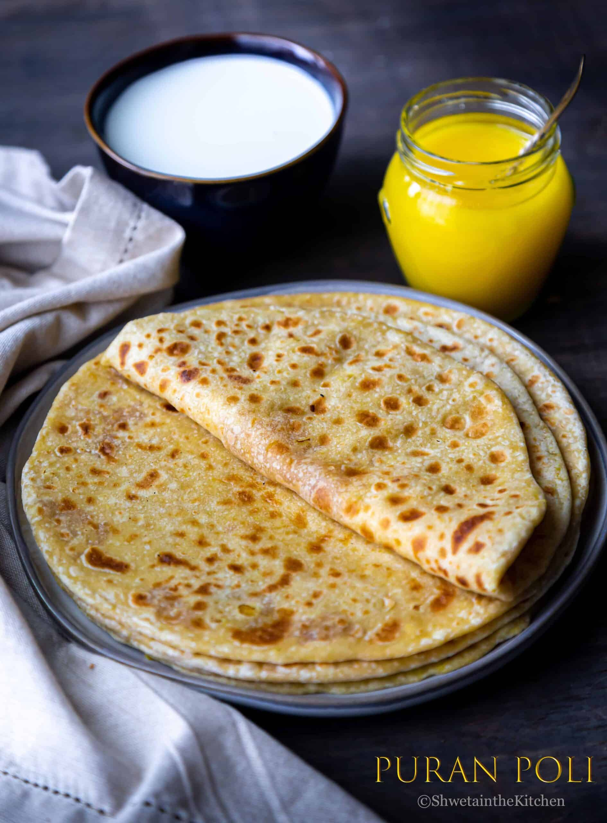
Lavani is a traditional and vibrant folk dance from Maharashtra, India, known for its powerful rhythm, fast tempo, and expressive storytelling. The name comes from the word lavanya, which means beauty.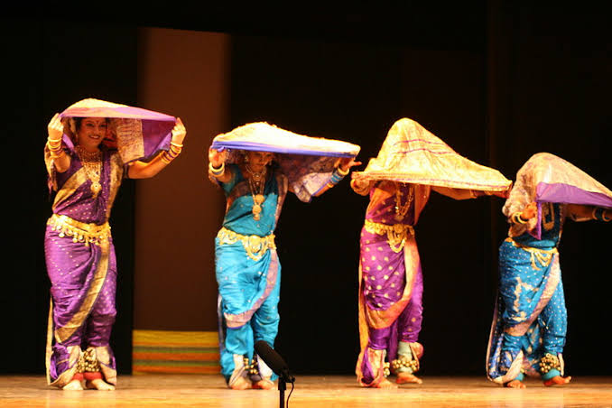 | The Gateway of India is an arch-monument, completed in 1924, on the waterfront of Mumbai, Maharashtra, India. It was erected to commemorate the landing of King George V of the United Kingdom for his coronation as the Emperor of India in December 1911 at Strand Road near Wellington Fountain.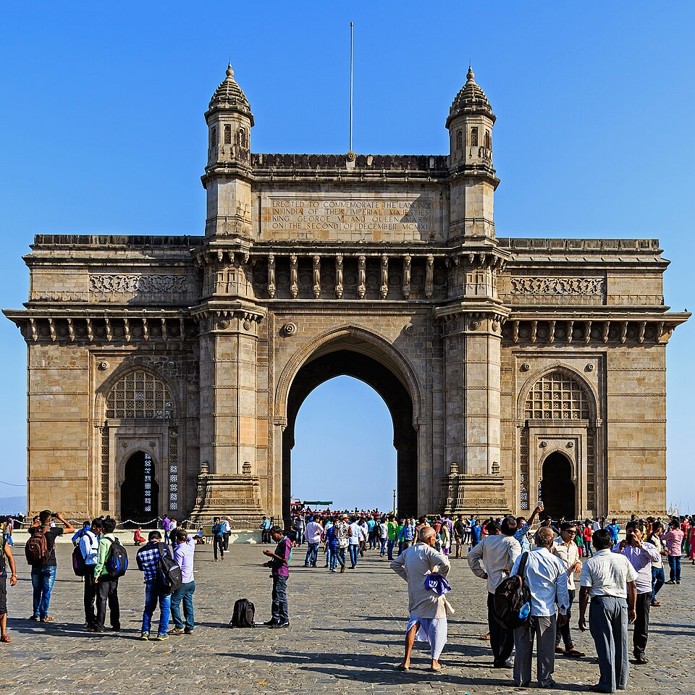
The traditional dress of Maharashtra includes the Nauvari saree for women and the dhoti with a pheta turban for men. These outfits show the rich history, brave culture, and old traditions of the state. 